**1.0 - Source Code Based Testing:**

**1.1 - Control Flow Based Testing:**

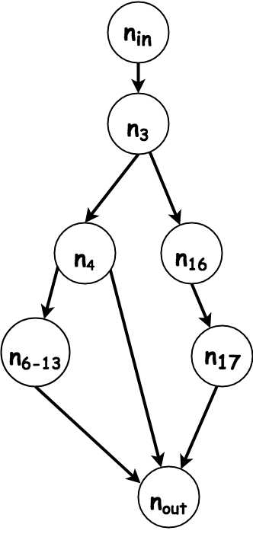

Only C2 path coverage is needed, since it subsumes all other control flow methods, and is attainable in this case with only 3 tests, which were already derived during specification based testing.

|  |  |  |  |  |  |
| --- | --- | --- | --- | --- | --- |
| **ID** | **PARAMETERS** | |  | **Coverage** | |
| game_id | gold_team_score | green_team_score | path | **%** |
| T_0_0 | 33 | 40 | 40 | In, 3, 4, 6-13, out | ⅓ = 33.3% |
| T_0_1 | -33 | 11 | 11 | In, 3, 4, out | ⅔ = 66.6% |
| T_0_2 | null | 10 | 10 | In, 3, 16, 17, out | 3/3 = 100% |

**1.2 - Data Flow Based Testing**

**Skipped as path coverage which was achieved above subsumes the all-use criteria**